**SUPPORTING INFORMATION**

**Gonyautoxin 1/4 Aptamers with High-affinity and High-specificity:  from efficient Selection to Aptasensor Application**

Shunxiang Gaoa,1, Bo Hua,b,1, Xin Zhenga,c,1, Ying Caod, Dejing Liua, Mingjuan Suna, Binghua Jiaoa,b,*, Lianghua Wanga,*

aDepartment of Biochemistry and Molecular Biology, College of Basic Medical Sciences, Second Military Medical University, Shanghai 200433, China.

bMarine Biological Institute, College of Marine Military Medicine, Second Military Medical University, Shanghai 200433, China.

cDepartment of Laboratory Diagnosis, Changhai hospital, Second Military Medical University, Shanghai 200433, China.

dBeijing Institute of Pharmaceutical Chemistry, Beijing 102205, China.

1Co-first authors

*Correspondence authors: Binghua Jiao, Lianghua Wang.

Department of Biochemistry and Molecular Biology, College of Basic Medical Sciences, Second Military Medical University, Shanghai 200433, China

Tel: 021-81870967; Fax: 86-21-65490178

E-mail: [bhjiao@smmu.edu.cn](mailto:bhjiao@smmu.edu.cn), [lhwang@smmu.edu.cn](mailto:lhwang@smmu.edu.cn)

**Materials and methods**

1. **Materials and Reagents**

All nucleic acid sequences were custom-synthesized by Sangon Biotech (Shanghai, China). GTX1/4, GTX2/3, STX and neoSTX were obtained from Taiwan Algal Science, Inc. (Taiwan). Dynabeads® M-270 Amine and the Qubit® ssDNA Assay Kit were purchased from Invitrogen. Graphene oxide dispersion (U grade) was procured from NANOON (Beijing, China). 1-Ethyl-3-(3-dimethylaminopropyl) carbodiimide hydrochloride (EDC), N-hydroxysuccinimide (NHS), 2-(N-morpholino) -ethanesulfonic acid (MES) and other chemical agents were purchased from Sigma-Aldrich Co. LLC (mainland, China). Dr. GenTLE® Precipitation Carrier and 20 bp DNA Ladder (Dye Plus) were procured from TaKaRa Bio, Inc. (Dalian, China). GoTaqHot® Start Colorless Master Mix was purchased from Promega Corporation (Shanghai, China). Uera (ultra-pure grade) was obtained from AMRESCO (Beijing, China). Bio Gel P-2 was obtained from Bio-Rad (Hercules, USA) and 3-mercaptopropionic acid from Fluka (Germany). BLI sensor chips were obtained from ForteBio (Shanghai). DNA-PAGE Buffer and binding buffer (pH 7.5, 20 mMTris-HCl, 100 mM NaCl, 2 mM MgCl2, 5 mMKCl) were procured from Tiandz (Beijing, China). Binding buffer was used for the aptamer selection, biolayer interferometry (BLI), and circular dichroism (CD) experiments. The elution buffer was binding buffer with 7 mM urea in it. MES buffer (pH 5.0) was used for the coupling of carboxylated GTX1/4 with the amine beads. All solutions were prepared using Milli-Q ultrapure water.

1. **Preparation of** **Carboxyl Derivatives of GTX1/4**

The carboxyl derivatives of GTX1/4 were prepared using the reaction described by Watanabe et al with some modification (Watanabe et al. 2006). Lyophilized GTX 1/4 (20 g) was dissolved in 5 mL of 50 mM phosphate buffer (pH 7.4) containing 100 mM 3-mercaptopropionic acid. The mixture was stirred at 70℃ for 1 h, and the reaction was quenched using 1.0 M acetic acid. The reaction mixture was lyophilized and dissolved in 50 mM acetic acid. The solution was applied to a Bio Gel P-2 column using 50 mM acetic acid as the mobile phase. Fractions containing GTX1/4 derivatives were collected and lyophilized.

1. **Preparation of GTX1/4** **Magnetic Beads**

Lyophilized GTX1/4 carboxyl derivatives (20 μg) were dissolved in 200 μL coupling buffer. Then, 60 mg of EDC and 60 mg of NHS were dissolved in 1 mL coupling buffer and mixed with the GTX1/4 carboxyl derivative solution. After incubation for 0.5 h at room temperature, 800 μL amino-beads, which were washed several times with coupling buffer, were added for a total volume of 2 mL. The mixture was rotated for 2 h at room temperature. After the reaction, the beads were washed several times with coupling buffer to remove the unreacted toxin. A 25 μL volume of propionic acid was diluted in 500 μL of coupling buffer. As before, EDC (60 mg) and NHS (60 mg) were dissolved in 1 ml coupling buffer and then incubated with propionate solution for 0.5 h at room temperature. Next, 1200 μL of the mixture was added to 800 μL of GTX1/4 beads to block the unreacted amine groups on the beads. The remaining 300 μL of mixture was added to 200 μL of washed amino-beads for negative selection. After another 2 h of end-over-end rotation at room temperature, the beads were washed extensively with binding buffer. Finally, GTX1/4 beads and negative beads were stored in binding buffer at 4 ℃ until use.

1. **In Vitro Selection of the DNA Aptamer**

*GO-SELEX*

The GO positive-SELEX and GO counter-SELEX process are illustrated in Fig. 1. For the GO-SELEX screening, specified amounts (1 nmol in the first selection round; 200 pmol in the subsequent GO positive-SELEX rounds and 120 pmol in the GO counter-SELEX rounds) of ssDNA library dissolved in binding buffer (pH 7.5, 20 mMTris-HCl, 100 mM NaCl,  2 mM MgCl2, 5 mMKCl) were heated to 95 °C for 10 min and cooled in an ice bath for 5 min to form the optimal structural conformation of oligonucleotides, then mixed with GTX1/4 (200 pmol). The mixture was incubated at 4 ℃ for 2 h, allowing the potential aptamer sequences from the ssDNA pool to bind to the target free in solution. Subsequently, 200 μL of 2 mg/mL GO solution was added to the mixture to a total volume of 1 ml and a GO concentration of 0.4 mg/mL, and then incubated for another 2 h with end-over-end rotation at room temperature to separate the ssDNA that did not bind to the target toxin. Next, the mixture was centrifuged at 15,000 rpm for 15 min three times, and 700 μl of the supernatant was collected, quantified and amplified, while the GO and ssDNA adsorbed on the GO surface were discarded. When the DNA recovery began to plateau after a significant increase in the positive selection round, the GO counter-SELEX was incorporated with the GO positive-SELEX to eliminate false-positive binding of aptamers. In the GO counter-SELEX process, three counter targets (STX, neoSTX and GTX1/4, total 120 pmol) were initially incubated with 120 pmol of the denatured ssDNA library for 1 h. Then, the GO was added and incubated for 1 h (final volume 1 mL, GO 0.4 mg/mL). The oligonucleotides in the mixture that bound to the counter targets in the supernatant were discarded by centrifugation, while the ssDNA that was adsorbed to the surface of GO was collected and washed three times with 1 ml binding buffer. Then, the ssDNA adsorbed on GO was incubated for 1 h with the target toxin GTX1/4. In the affinity-based competitive capture process, ssDNA desorbed from the GO surface was collected, quantified and amplified.

*MB-SELEX*

The MB-SELEX processes are illustrated in Fig. 1, following the protocol detailed in Table S1. For the MB-SELEX screening, the ssDNA pool dissolved in binding buffer was first denatured and refolded as before. At the same time, the GTX1/4 beads were washed several times with binding buffer. Then, the prepared library was immediately added to wash the GTX1/4 beads in 500 μL binding buffer in a microcentrifuge tube, followed by incubation with end-over-end rotation at room temperature. The beads were then washed several times with 500 μL aliquots of binding buffer until no DNA could be detected in the supernatant. The ssDNA bound to GTX1/4 beads was eluted with 500 μL elution buffer three times with shaking and heating at 95 °C for 15 min. The eluted ssDNA was recovered, quantified and amplified. For the counter-SELEX screening, the ssDNA library, subjected to the same heating and cooling treatment as before, was first incubated with the negative beads; the ssDNA in the supernatant was then recovered and quantified. After another heating and cooling treatment, the ssDNA was subsequently incubated with GTX1/4 beads, and free competitive counter-targets (STX, neoSTX and GTX2/3) were added to the mixture at the same time. After incubation at room temperature, the GTX1/4 beads were washed and eluted as before. The eluted ssDNA bound to GTX1/4 beads in the elution buffer was quantified using a Qubit® 2.0 Fluorometer, purified by ethanol precipitation, and amplified by PCR.

Table S1. Summary of selection protocol for MB-SELEX

|  |  |  |  |  |
| --- | --- | --- | --- | --- |
| Selection round | Amount of ssDNA pool ( pmol ) | Negative  selections | Competitors ( counter target )in  positive incubation system | Incubation  time (min) |
| 1 | 1000 | no | no | 120 |
| 2 | 200 | counter-beads | no | 120 |
| 3 | 200 | counter-beads | STX (200 pmol) | 90 |
| 4 | 200 | counter-beads | neoSTX (200 pmol) | 90 |
| 5 | 200 | counter-beads | GTX2/3 (200 pmol) | 90 |
| 6 | 120 | counter-beads | STX, neoSTX, GTX2/3 (total 120 pmol) | 60 |
| 7 | 120 | counter-beads | STX, neoSTX, GTX2/3 (total 120 pmol) | 60 |
| 8 | 120 | counter-beads | STX, neoSTX, GTX2/3 (total 120 pmol) | 60 |

The MB-SELEX and GO-SELEX enriched and precipitated pools (5′-AGCAGC ACAGAGGTCAGATG-N40-CCTATGCGTGCTACCGTGAA-3′) were amplified by PCR in 40 parallel 50 μl reactions, each containing Go Taq® Hot Start DNA Polymerase and Colorless Go Taq® Reaction Buffer (pH 8.5), 200 μM dNTP, 2 mM MgCl2 and 0.5 μM forward and reverse primers. The forward primer was 5′-AGCAG CACAGAGGTCAGATG-3′; the reverse primer was 5′-TTCACGGTAGCACGCAT AGG-3′; the modified reverse primer was 5′-poly (dA20)-Spacer18-TTCACGGTAGC ACGCATAGG-3′; and PCR conditions were as follows: 94 °C for 1 min, followed by 25 cycles of 95 °C for 30 s, 60 °C for 30 s, 72 °C for 30 s, and a final extension step of 2 min at 72 °C. PCR products were used for relevant DNA strand separation by 12% urea denaturing PAGE, and the ssDNA was recovered by boiling the gel band. The eluted ssDNA in binding buffer was collected and purified by ethanol precipitation and dried at room temperature for 30 min. Finally, the dried ssDNA powders were dissolved in binding buffer and used for the next selection round.

1. **Cloning and Sequencing of Selected DNA**

After round 8, two ssDNA pools selected by MB-SELEX and GO-SELEX were amplified with unmodified primers. The purified PCR products were then cloned and sequenced by Shanghai Sangon Biological Science and Technology Company (Shanghai, China). The resulting ssDNA sequences were aligned and analyzed using the Clustal X software. Their secondary structures were predicted by the mfold Web Server (<http://mfold.rna.albany.edu/?q=mfold>).

1. **Affinity Determination by Binding Affinity Assays**

Different concentrations (0−1 μM) of aptamers selected by GO-SELEX and MB-SELEX in binding buffer were incubated with 10 μL of GTX1/4 beads in a centrifuge filter tube after being subjected to a heating and cooling treatment similar to the selection step. The beads were washed several times and the bound DNA eluted, and the aptamers eluted from each sample were quantified using a Qubit® 2.0 Fluorometer. A saturation curve of the amount of aptamer eluted against the GTX1/4 concentration was obtained, and the affinity constants (*K*d) for GTX1/4 were calculated by nonlinear regression analysis.

1. **Aptasensor Preparation**

Amine Reactive Second-Generation (AR2G) biosensors, streptavidin-coated (SA) Biosensors and Super streptavidin-coated (SSA) biosensors were used for the online immobilization of GTX1/4 aptamer onto the aptasensors. The online preparation process of SA and SSA aptasensors includes three steps: (1) sensor activation (2 min); (2) biotinylated aptamer immobilization (5 min); and (3) washing (3 min). The preparation process for AR2G aptasensors includes five steps: (1) baseline (2 min); (2) EDC/NHS activation (30 min); (3) washing (3 min); (4) aminated aptamer immobilization (30 min); (5) washing (3 min). The aptasensor responses acquired from the reaction surface were also adjusted by subtracting the signal data obtained from the control surface to eliminate nonspecific binding and any buffer-induced interferometry spectrum shift.

1. **Conformation analysis by** **CD**

The conformation of the DNA aptamer at different detection conditions was studied using a J-715 CD spectropolarimeter. The assay was conducted in a 1 cm path length quartz cuvette in an optical chamber with 1.0 µM GO18-T-d aptamer and 2 μM GTX1/4 in binding buffer with varying pH. The background signals of the binding buffer and 2 μM GTX1/4 in binding buffer were measured and subtracted from the CD spectra. Before use, the [chamber was deoxygenated with dry purified nitrogen (99.99%). During the experiments, the CD spectra were measured in an instrument filled with pure [nitrogen](http://en.wikipedia.org/wiki/Nitrogen) gas. At wavelengths [from](C:/Users/lenovo/Desktop/%E6%96%87%E7%AB%A0%E6%9F%A5%E9%87%8D/javascript:void(0);) 220 nm [to](C:/Users/lenovo/Desktop/%E6%96%87%E7%AB%A0%E6%9F%A5%E9%87%8D/javascript:void(0);) 320 [nm, CD spectra were recorded at intervals of 0.1 nm and a speed of 20 nm/min, with a 1 nm](C:/Users/lenovo/Desktop/%E6%96%87%E7%AB%A0%E6%9F%A5%E9%87%8D/javascript:void(0);) bandwidth [and a time constant of 1 s.](C:/Users/lenovo/Desktop/%E6%96%87%E7%AB%A0%E6%9F%A5%E9%87%8D/javascript:void(0);)](C://Users/lenovo/Desktop/%E6%96%87%E7%AB%A0%E6%9F%A5%E9%87%8D/javascript:void(0);)

1. **GTX1/4 Extraction from shellfish samples**

Shellfish extraction was performed by the AOAC 2005.06 double extraction acid procedure (Lawrence et al. 2004). Briefly, samples (5 ± 0.1 g) of shucked shellfish homogenate were weighed into a centrifuge tube, and 3 mL of 1% acetic acid in water was added, which was then shaken for 90 s on a vortex mixer. Samples in the sealed centrifuge tubes were boiled for 5 minutes, cooled to room temperature in an ice water bath, and then shaken for another 90 s. After mixing, samples were centrifuged at 4500 rpm for 10 min, and the supernatant was collected. The homogenate was extracted by repeating the same procedure. The collected supernatant was evaporated in a speedVac concentrator, and the residue was resuspended in 200 µL of optimized binding buffer (20 mMTris-HCl, 10 mM MgCl2, pH 7.5).

**Supporting Results**

1. **Chemical structures of gonyautoxin group**



Fig. S1. Chemical structures of GTX1/4, GTX2/3, STX, and neoSTX.

1. **Preparation of GTX1/4 Magnetic Beads**



GTX1/4

GTX1/4-caboxylated derivative

GTX1/4 Magnetic Beads

Fig. S2. Preparation of GTX1/4-caboxylated derivative and GTX1/4 Magnetic Beads.

1. **Multiple sequence alignment of the selected sequences by GO-SELEX**

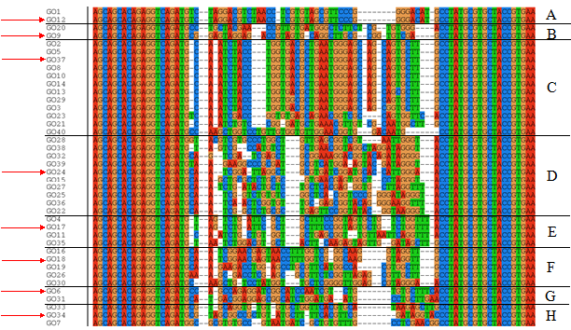

Fig. S3. Multiple sequence alignment of sequences obtained using GO-SELEX by Clustal X software. These sequences were grouped based on conservation into 8 families (A-H), and a representative sequence was chosen from each group for further analysis (GO12, 9, 37, 24, 17, 18, 6, and 34).

1. **Multiple sequence alignment of the selected sequences by MB-SELEX**

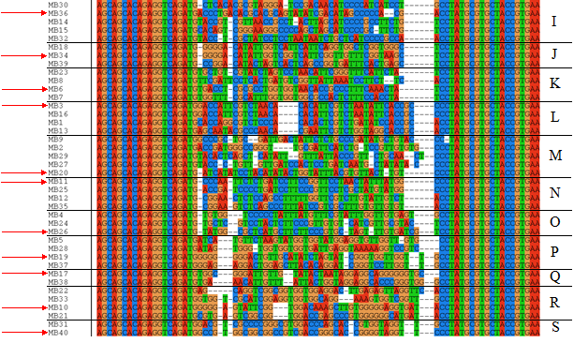

Fig. S4. Multiple sequence alignment of sequences obtained using MB-SELEX by Clustal X software. These sequences were grouped based on conservation into 11 families (I-S), and a representative sequence was chosen from each group for further analysis (MB36, 34, 6, 3, 20, 11, 26, 19, 17, 10, and 40).

1. **Affinity constant (*K*d) between GTX1/4 and selected aptamers**

Table S2. Sequences and Affinity constant between GTX1/4 and selected aptamers

|  |  |  |  |
| --- | --- | --- | --- |
| Group | Clone no | Aptamer sequence | *K*d (M)* |
| A | GO 12 | AGCAGCACAGAGGTCAGATGTCTAGGACGTCTAACCTCGT  GTAGCGTTCCCGGGGACATGCCTATGCGTGCTACCGTGAA | 6.53×10-7 |
| B | GO 9 | AGCAGCACAGAGGTCAGATGCGGAGTAGGAGACCGTAGTG  CAGGCTTGCGCGGTGTCGAGCCTATGCGTGCTACCGTGAA | 1.09×10-7 |
| C | GO 37 | AGCAGCACAGAGGTCAGATGCAATCTACCTGGTGACGCTG  AATGGGAGCAGCAGTGCTTGCCTATGCGTGCTACCGTGAA | 2.54×10-7 |
| D | GO 24 | AGCAGCACAGAGGTCAGATGCAATCGGATTAGGCTGCGTG  ATCGGATGCACCATTGGGAACCTATGCGTGCTACCGTGAA | NB |
| E | GO 17 | AGCAGCACAGAGGTCAGATGTAGTCTGATTCGCTGCTTTC  CGGTAGTGCTGTCTGGTTTACCTATGCGTGCTACCGTGAA | 5.61×10-7 |
| F | GO 18 | AGCAGCACAGAGGTCAGATGCAATCGGAACGAGTAACCTT  TGGTCGGGCAAGGTAGGTTGCCTATGCGTGCTACCGTGAA | 6.20×10-8 |
| G | GO 6 | AGCAGCACAGAGGTCAGATGCCAGCCAGAGGATCGGCAT  CCAATCGTCTGTGTGCTTTCACCTATGCGTGCTACCGTGAA | NB |
| H | GO 34 | AGCAGCACAGAGGTCAGATGCGTAGCGGCCGCTGTATGCT  TTTCACGTTCGGATAGGTACCCTATGCGTGCTACCGTGAA | 3.58×10-7 |
| I | MB 36 | AGCAGCACAGAGGTCAGATGACCCTGACACGCACGCAGTA  TATCGACATAGCCCCCACGACCTATGCGTGCTACCGTGAA | NB |
| J | MB 34 | AGCAGCACAGAGGTCAGATGGGGGACATATTGGTCGGTCA  TTCGGTTGTTTCGGTAAGCTCCTATGCGTGCTACCGTGAA | NB |
| K | MB 6 | AGCAGCACAGAGGTCAGATGTGACCTCGCGCCTGGTGGT  AACACCGCCCTTTCAAACTATCCTATGCGTGCTACCGTGAA | NB |
| L | MB 3 | AGCAGCACAGAGGTCAGATGGACCATTCGTCTAACACAC  ATTCGTCTAATATTCACCGCCCCTATGCGTGCTACCGTGAA | 4.42×10-6 |
| M | MB 20 | AGCAGCACAGAGGTCAGATGATCATATCCTACATATACTG  GTATTTACGTGTTACTTGTCCCTATGCGTGCTACCGTGAA | NB |
| N | MB 11 | AGCAGCACAGAGGTCAGATGCCCAATTCTCTGATCCTTCC  GGTTCCTAACTATTTATGGCCCTATGCGTGCTACCGTGAA | 1.19×10-5 |
| O | MB 26 | AGCAGCACAGAGGTCAGATGTATGGCGCTCATGCTTCTTC  CCGTGCTAGTTTGTGATCGTCCTATGCGTGCTACCGTGAAA | NB |
| P | MB 19 | AGCAGCACAGAGGTCAGATGGGGGGGGACTGTTGCATAT  CTAGTATCGGGTGGTTGGTTGCCTATGCGTGCTACCGTGAA | NB |
| Q | MB 17 | AGCAGCACAGAGGTCAGATGTGGCGGGATTGTTGTATACT  AATAGGAGGCAGGGGGGTGCCCTATGCGTGCTACCGTGAA | NB |
| R | MB 10 | AGCAGCACAGAGGTCAGATGGGGGAGTATTCGGTGGACA  AAGCTTGTGGGGGAGGTGATACCTATGCGTGCTACCGTGAA | 2.31×10-5 |
| S | MB 40 | AGCAGCACAGAGGTCAGATGGCCGTGGCGGCGGCCGTCGA  CCGGGCACCGGGGTAGGTTCCCTATGCGTGCTACCGTGAA | NB |

*NB: Not bound.

1. **Truncated aptamer sequences and their affinity constant (*K*d) with GTX1/4**

Table S3. Sequences and affinity constant between GTX1/4 and truncated aptamers

|  |  |  |
| --- | --- | --- |
| Names | Sequences | *K*d (nM)* |
| GO18 | AGCAGCACAGAGGTCAGATGCAATCGGAACGAGTAACCTT  TGGTCGGGCAAGGTAGGTTGCCTATGCGTGCTACCGTGAA | 62.0 |
| GO18-T | CAATCGGAACGAGTAACCTTTGGTCGGGCAAGGTAGGTTG | 60.9 |
| GO18-T-a | TAACCTTTGGTCGGGCAAGGTAGGTTG | 22.5 |
| GO18-T-b | TAACCTTAGGTAGGTTG | NB |
| GO18-T-c | TAACCTGGTCGGGCAGGTTG | NB |
| GO18-T-d | AACCTTTGGTCGGGCAAGGTAGGTT | 21.9 |

*NB: Not bound.

1. **Secondary structure prediction of the aptamers using mfold program**

**a c**

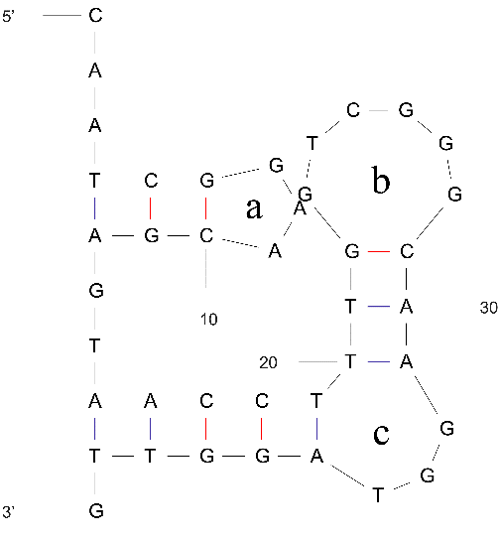 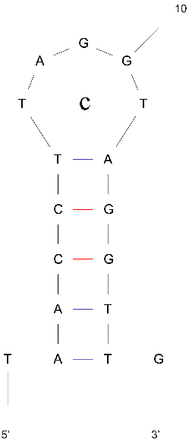

**b d**

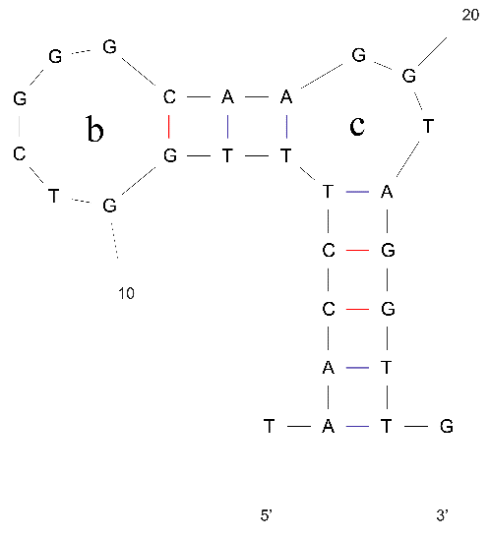 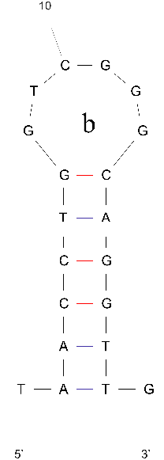

**e**

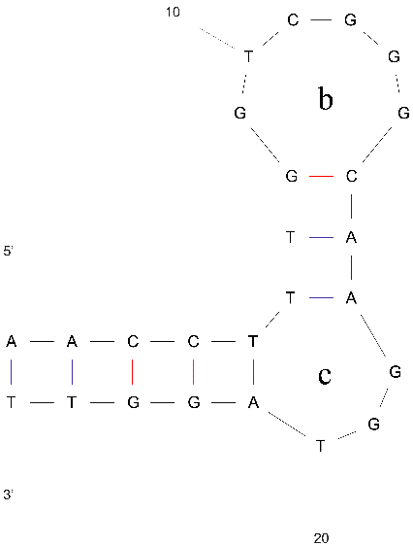

Fig. S5. Secondary structure of truncation sequences for aptamer GO18. (a) GO18-T, (b) GO18-T-a, (c) GO18-T-b, (d) GO18-T-c, (e) GO18-T-d.

1. **BLI technology assay principle process**

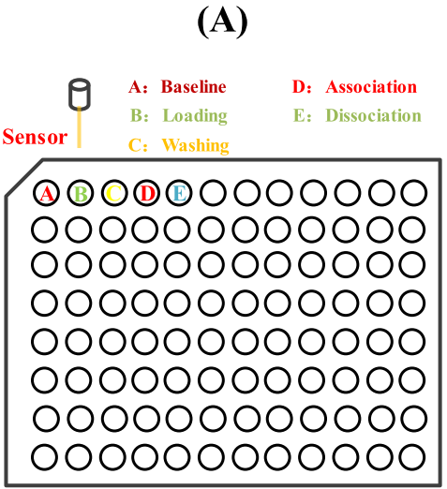

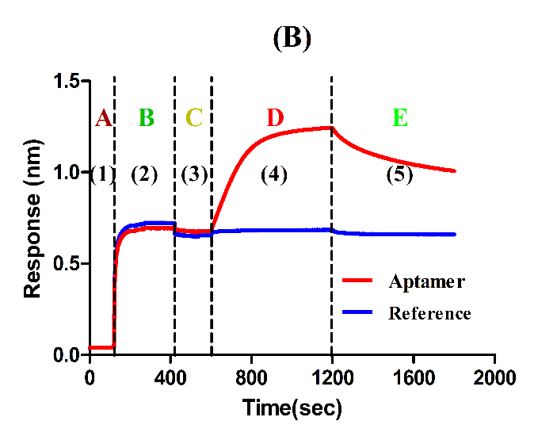

Fig. S6. BLI systemassay process includes five steps: (1) baseline (2 min); (2) loading (5 min); (3) washing (3 min); (4) association (10 min); (5) baseline (10 min). A reference sensor is always required as a control in every assay.

1. **BLI technology assay principle**

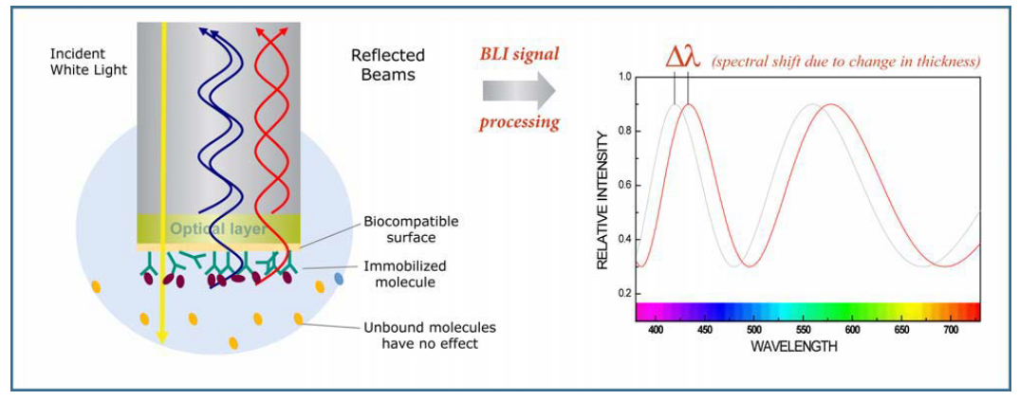

Fig. S7. BLI systemassay principle (Concepcion et al. 2009).

1. **Application of the GTX1/4 aptasensor in spiked shellfish** **samples**

Table S4. Recovery studies of shellfish samples at three levels by aptasensor

|  |  |  |  |  |  |
| --- | --- | --- | --- | --- | --- |
| shellfish samples | Spiked shellfish GTX1/4 (ng/mL) | Theoretical response of GTX1/4 in BB | Average response of GTX1/4  in spiked sample±SD | Recovery (%) | CV  (%) |
| 1 | 5 | 0.0391 | 0.0339±0.0021 | 86.70 | 86.70 |
| 2 | 30 | 0.162 | 0.154±0.0039 | 95.06 | 95.06 |
| 3 | 60 | 0.309 | 0.313±0.0011 | 101.29 | 101.29 |

**References**

Concepcion, J., Witte, K., Wartchow, C., Choo, S., Yao, D., Persson, H., Wei, J., Li, P., Heidecker, B., Ma, W., Varma, R., Zhao, L.S., Perillat, D., Carricato, G., Recknor, M., Du, K., Ho, H., Ellis, T., Gamez, J., Howes, M., Phi-Wilson, J., Lockard, S., Zuk, R., Tan, H., 2009. Comb Chem High Throughput Screen. 12, 791-800.

Lawrence, J.F., Niedzwiadek, B., Menard, C., 2004. [J AOAC Int.](http://www.ncbi.nlm.nih.gov.ejournal.mahidol.ac.th/pubmed/?term=Quantitative+determination+of+paralytic+shellfish+poisoning+toxins+in+shellfish+using+prechromatographic+oxidation+and+liquid+chromatography+with+fluorescence+detection%3A+collaborative+study.) 87, 83-100.

Watanabe, R., Samusawa-Saito, R., Oshima, Y., 2006. [Bioconjug Chem.](http://www.ncbi.nlm.nih.gov.ejournal.mahidol.ac.th/pubmed/?term=Development+of+saxitoxin-conjugated+affinity+gels) 17, 459-465.